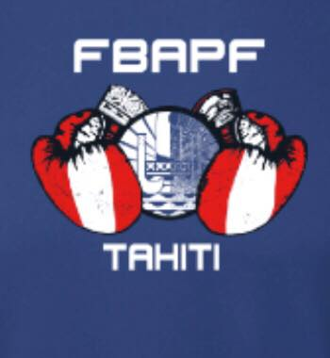
N° | POIDS | Phase |  | OR |  | ARGENT | BRONZE
1 | 36-39 kg  benjamins | F | 3 X 1’30 | TEUA Manaoarii  Toroura BC |  | TARA Tama  Ah Min BC | TEOTAHI Heifara/ Taiarapu BC  TUTAVAE Vaiari /Taiarapu BC
2 | 39-45 kg  benjamins | F | 3 X 1’30 | YUEN Evan  As Tamarii Toroura |  | ATIU Heifara  Ah-Min BC | 0
3 | + 45 kg  benjamins | F | 3 X 1’30 | MENDELSOHN Teriirau  Toa BC |  | ARAI Timanu  Tiatoa BC | 0
4  filles | 51 kg  minimes | F | 3 X 1’30 | TETUAITEROI Cynthia  TFS BC |  | ALPHONSI Orihei  Ah Min BC | 0
5  filles | 57 kg  minimes | F | 3 X 1’30 | TOOFA Kahaia  Taiarapu BC |  | YUN SHAN FAT Vedelya  Outumaoro BC | 0
6 | 48 kg  minimes | F | 3 X 1’30 | TAIORE Keny  Mahina BC |  | BOURBE Raiala  Moorea BC | ATIU Tahaki /Ah Min BC
7 | 54 kg  minimes | F | 3 X 1’30 | RANGIVARU Vehiatua  Taiarapu BC |  | LEAU KANG MUI Marama  Haamene BC | 0
8 | 60 kg  minimes | F | 3 X 1’30 | TEIHOARII Teamana  Taiarapu |  | MATUANUI Moanatea  Toroura | 0
9 | 69 kg  minimes | F | 3 X 1’30 | MARAE Keanuhei  Tiatoa BC |  | AUBERTINI Terainui  Ah Min BC | HAOA Jean-Marie /Mahina BC
N° | 69 kg  juniors  POIDS | F  Phase | 3 X 2’ | TEPAKOU Toriki  Ah Min BC  OR |  | TEAHI John  Tamarii Tuhaa Pae  ARGENT | LEFORT Rabine / Paea BC  REID Ariiura/ NTRF BC  BRONZE
10  filles | 48 kg  cadets | F | 3 X 2’ | HATITIO Hinatea  Ah Min BC |  | YUNE Keilani  Ah Min BC | 0
11  filles | 66 kg  cadets | F | 3 X 2’ |  |  |  | 0
12  filles | + 80 kg  cadets | F | 3 X 2’ | AUTAI Hinenao  Ah Min BC |  | MARAE Ranihei  Tiatoa BC | 1  TEMARONO Erena/Moorea BC
13 | 57 kg  cadets | F | 3 X 2’ | GRAND-PITTMAN Aretini  Moorea BC |  |  | 0
14 | 63 kg  cadets | F | 3 X 2’ | SNOW Mihinoa  Ah Min BC |  | MENDELSOHN Johan  Toa BC | TUFAUNUI Timivai/Paea BC
15 | 66 kg  cadets | F | 3 X 2’ | PAITI Akehau  Moorea BC |  | DUVAL Ariioehau  Paea BC | 0
16 | 70 kg  cadets | F | 3 X 2’ | LY Niuhiti  Paea BC |  | DAUPHIN Gabriel  TFS BC | 0
17 | 80 kg  cadets | F | 3 X 2’ | RAUHURI Aaron  Mahina BC |  | HIKUTINI Imapavai  Toroura BC | 0
18 | + 80 kg | F | 3 x 2’ | TEIO Tehau  Ah Min BC |  | BRODIEN Maruarii  Ah Min BC | 0

